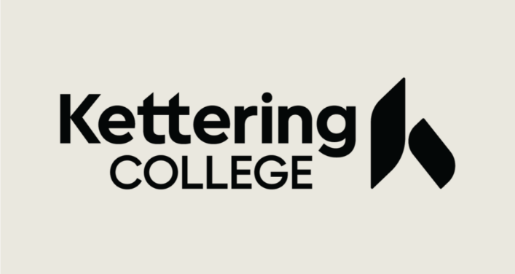
2022-23 Statement of Educational Purpose
Identity and Statement of Educational Purpose
(To Be Signed with Notary, cannot be virtual)

If the student is unable to appear in person at ___Kettering College ___________________
(Name of Postsecondary Educational Institution)
to verify his or her identity, the student must provide:

- A copy of the valid government-issued photo identification (ID) that is acknowledged in the notary statement below, such as but not limited to a driver’s license, other state-issued ID, or passport; and

(b) The original notarized Statement of Educational Purpose provided below.

Statement of Educational Purpose

I certify that I _____________________________ am the individual signing this
(Print Student’s Name)
Statement of Educational Purpose and that the federal student financial assistance I may receive will only be used for educational purposes and to pay the cost of attending _Kettering College__________ for 2022-2023 school year.
(Name of Postsecondary Educational Institution)

_________________________________________ _________________________
(Student’s Signature) (Date) (Student’s ID Number)

Notary’s Certificate of Acknowledgement
State of ________________________________________________________________________
City/County of ___________________________________________________________________
On_____________________, before me, ____________________________________________,
(Date) (Notary’s name)
personally appeared, ____________________________________________, and provided to me
(Printed name of signer)
on basis of satisfactory evidence of identification _______________________________________
(Type of government-issued photo ID provided)
to be the above-named person who signed the foregoing instrument.

WITNESS my hand and official seal
(seal) ________________________________________
(Notary signature)
My commission expires on _________________________
(Date)

