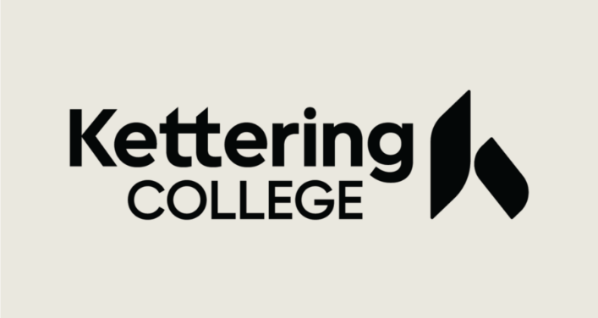

2022-2023 Statement of Educational Purpose

Identity and Statement of Educational Purpose
(To Be Signed at the Institution)

The student must appear in person at Kettering College to verify his or her identity by presenting valid government-issued photo identification (ID), such as, but not limited to, a driver’s license, other state-issued ID, or passport. The institution will maintain a copy of the student’s photo ID that is annotated with the date it was received and the name of the official at the institution authorized to collect the student’s ID.

In addition, the student must sign, in the presence of the institutional official, the following:

Statement of Educational Purpose

I certify that I _____________________________ am the individual signing this
(Print Student’s Name)
Statement of Educational Purpose and that the federal student financial assistance

I may receive will only be used for educational purposes and to pay the cost of attending

_____________Kettering College______ for 2022-2023 school year.
(Name of Postsecondary Educational Institution)

____________________________________ ______________
(Student’s Signature) (Date)

____________________________________

(Student’s ID Number)

Witness Signature and Date
______________________________________________

